- Try to say these words – hear them by clicking the blue box.
French | English
Les pâques | Easter
Un lapin | A rabbit
Un panier | A basket
Un oeuf | An egg
Une crêpe | A pancake
La chasse | The hunt
Un beignet | A doughnut
Une masque de carnaval | A carnival mask
Des cendres | Ashes
Une cloche | A bell
Un rameau | A branch
Un poussin | A chick
Une poule | A hen
Un agneau pascal | An Easter lamb
printemps | Spring
Des fleurs | Some flowers
Les oeufs de pâques | Easter eggs
Joyeuses Pâques! | Happy Easter
La chasse aux oeufs. | The egg hunt
Écoutez et répétez! Listen and repeat (click box)
- Find out about Easter in France by looking at these:
https://www.youtube.com/watch?v=lVTx0yuq4BQ

- Draw some Easter pictures like these and next to each picture, write down the French word.
Or print these if you can and cut them out to make a collage – labelling the pictures in French.
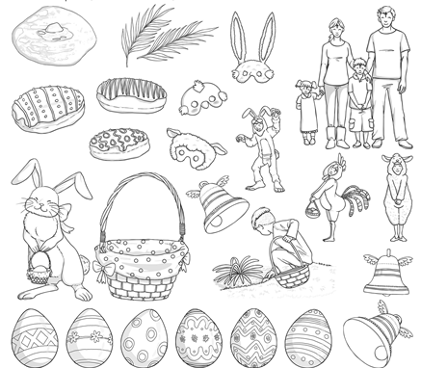

- Try these Easter egg French colour by numbers
